Practical No 5
Configuring a Zone-Based Policy Firewall
Network:
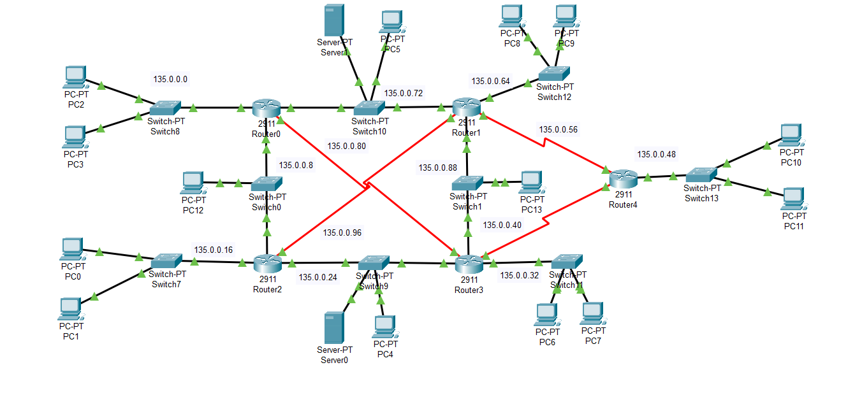

Ssh configuration on router5
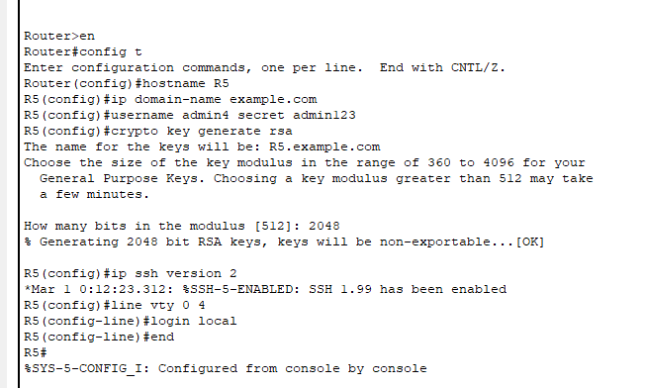

Installing the securityK9 package on router5

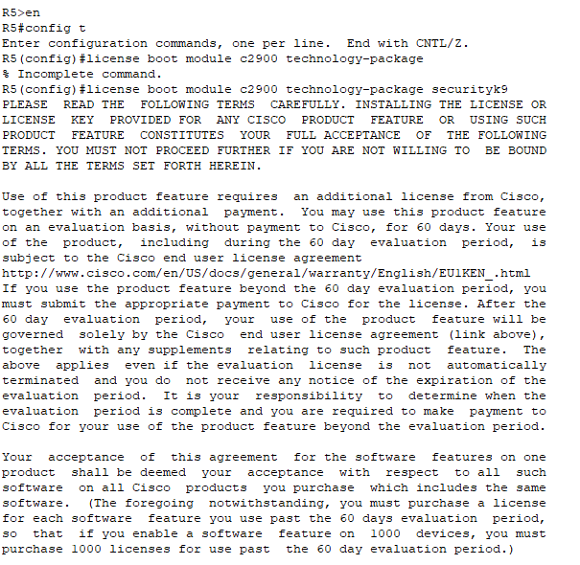

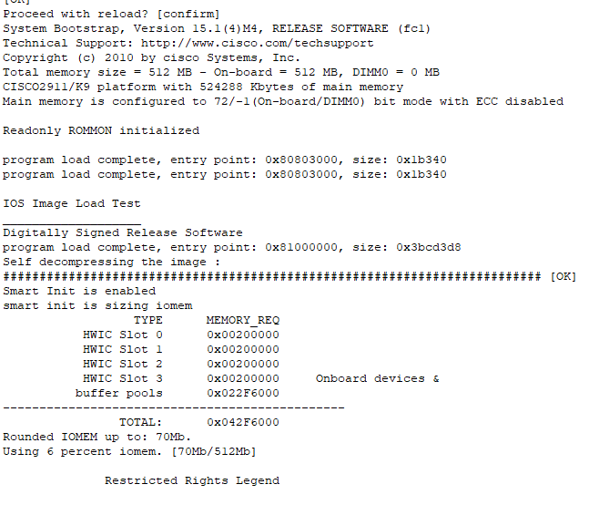

Creating zones for each network.
Router5 has 4 interfaces and for each interface Zone is created with different policies
ZONE-32 denies the icmp(ping) in a network

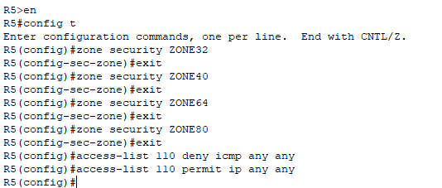

ZONE40 denies the HTTP and FTP service in a network
ZONE64 denies only FTP service in a network
ZONE80 denies the Ssh service in a network
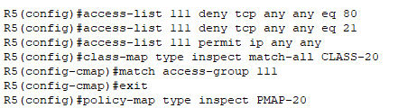

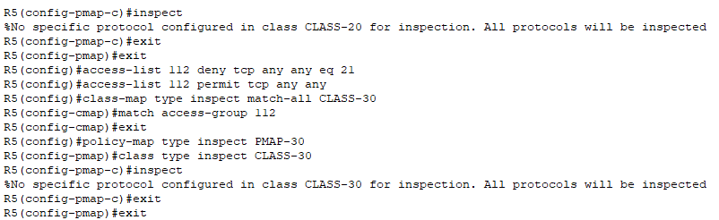

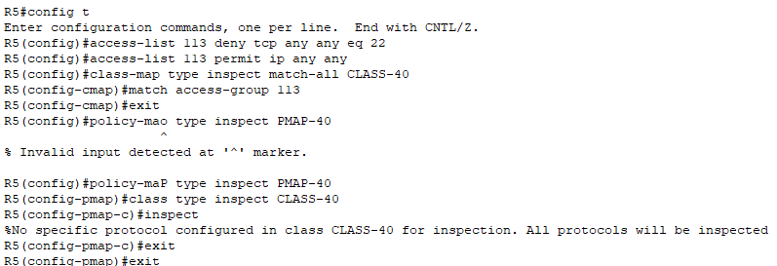

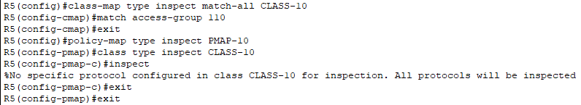
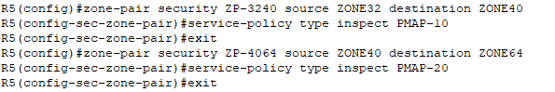
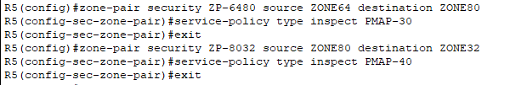

Assigning the zones to the interface
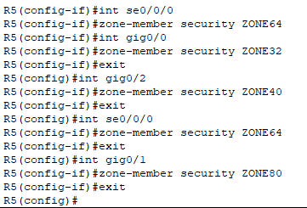
All the policies that are applied on each interface
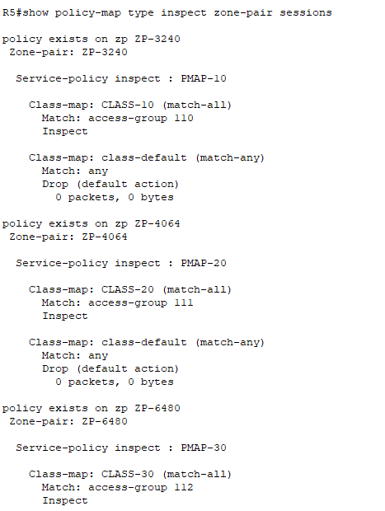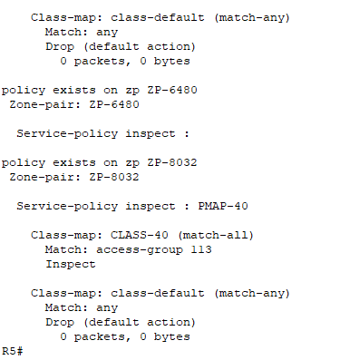

Zone32 policies
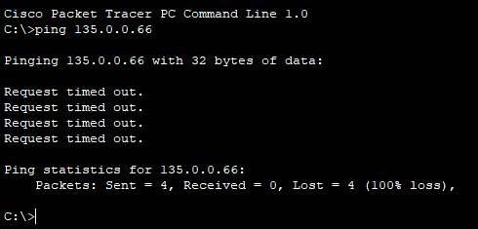

Zone40 policies
Denied the HTTP service
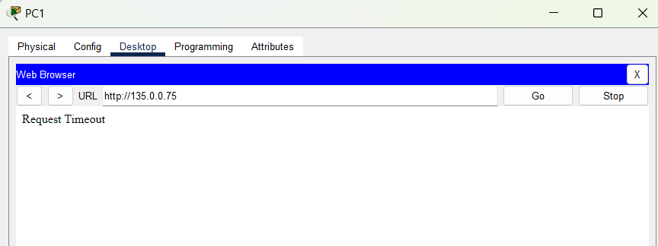
ZONE64
Denied the FTP service from server
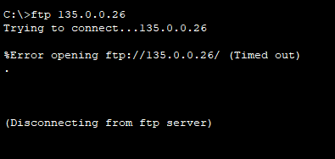

Zone80
Denied the ssh service
